Step 0 Intake + Interview Filing Status, Dependency
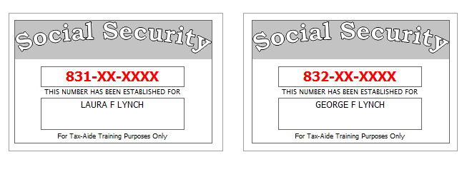
Laura had a serious accident in June, 2014, and stopped working. Laura is now totally and permanently disabled (per SSA Guidelines).
Laura’s divorce decree states that her ex-husband is to claim their son, John, as a dependent on his return even though Laura provides all the support for their children. Laura has provided her ex a signed form 8332 to facilitate this.
Reference: 4012 Tab A, B, C
Tool: IRS Interactive Tax Assistant (link on Preparer page)
Tool: AARP Resource Tool for Counselors (Laminated Flow Chart)
Tool: TP4F Qualifying Child/Qualifying Relative Flowchart Tool (link on Preparer page)
Tool: Dependent Calculator (link on Preparer page)

Step 1 Basic Information
Use the Filing Status from Step 0
Use Intake Sheet and Social Security cards
Extra Interview information for New Jersey:
- All dependents have health insurance (as of the time the return is filed)
- Laura wants her contribution to the Gubernatorial Election Campaign Fund to be handled the same as her contribution to the Presidential Election Campaign Fund.
Reference: 4012 K-3 to K-4
Tool: NJ Municipality Code Lookup Tool (link on Preparer page)
Tool: NJ 1040 Instructions – Municipality Code Table
Hint: For Profile, use Basic (No Profile)
Hint: Use names from SS Cards (NOT Intake Sheet)
Hint: A simple NJ return will be added after filling in the Federal Personal Information screen. Answer only the subset of the NJ Basic questions asked
Hint: Do not go to the State Section and do anything until you are done with the Federal Section and Health Insurance sections. Use the NJ Checklist to record things you will need to remember when doing the State Section later.
Hint: You do not need to remember or record the NJ PIN
NJ: Fill in Basic Information section of NJ Checklist and the Disability status line in the Subtractions from Income section now
Federal Refund: 0 NJ Refund Amount: 0
Step 2 Prior Year Return – State Income Tax Refund
Laura had a NJ refund of $502.
She did not itemize last year.
Federal Refund: 0 NJ Refund Amount: 0
Step 3 W-2
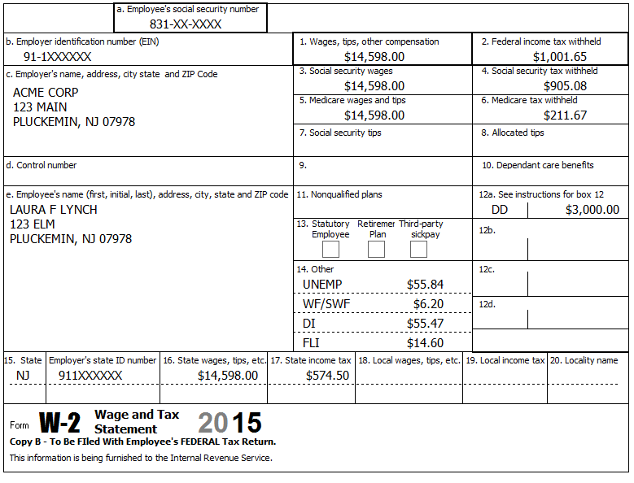
Reference: 4012 D-9 to D-10
Federal Refund: 7,550 NJ Refund Amount: 2,239
Step 4 W-2
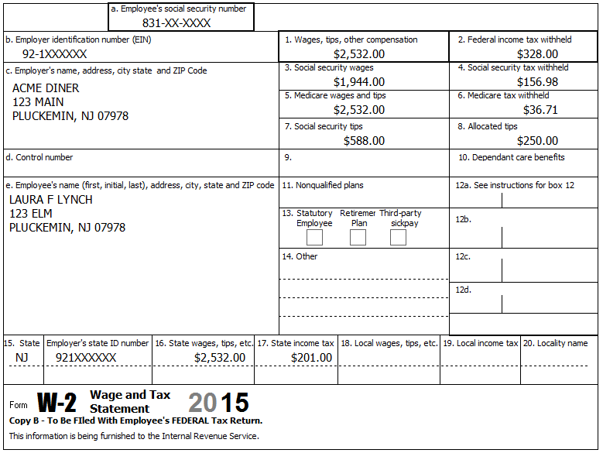
10.76 UI/WF/SWF
72.06 DI
2.53 FLI
Reference: 4012 D-9 to D-10
Hint: TSO may complain about the Social security tax in box 4 – Verify that your numbers match the form – if so, you can ignore this annoying complaint.
Federal Refund: 7,844 NJ Refund Amount: 2,487
Step 5 1099-R
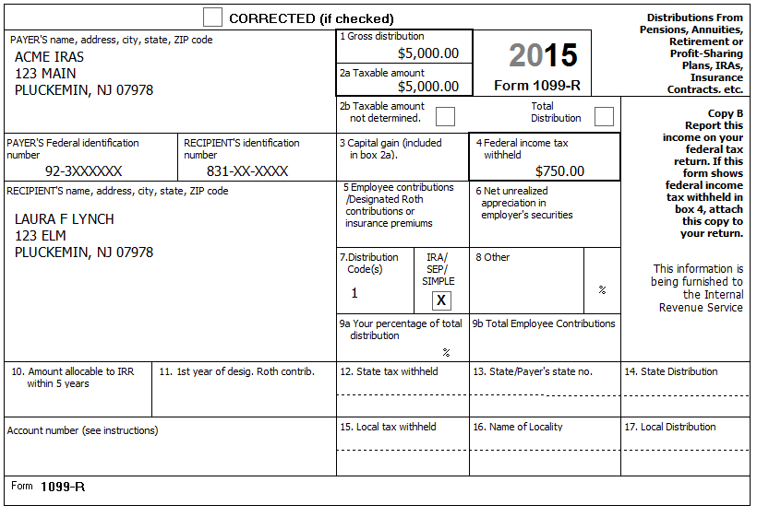
In January, Laura took an IRA distribution of $5,000 to pay off credit card debt.
Reference: 4012 D-17 to D-24
Step 5a 1099-R
Hint: Remember, Laura is permanently and totally disabled.
Federal Refund: 6,697 NJ Refund Amount: 1,943
Step 5b 5329
Reference: 4012 H-1 to H-2
BP: Enter 5329 info now so we don’t forget.
Federal Refund: 7,197 NJ Refund Amount: 1,943
Step 6 1099-R
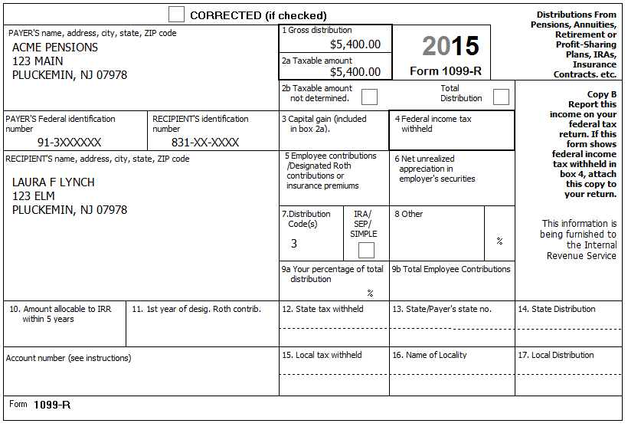
Reference: 4012 D-17 to D-24
The minimum retirement age for Laura’s job was 59.
NJ: Record disability amount on NJ Checklist (Adjustments to Line 19a)
Federal Refund: 5,520 NJ Refund Amount: 1,509

Step 7 Self Employment
Starting on July 1, 2011, Laura started providing freelance editing services from her home.
She met all scope requirements (see Pub 4012).
Reference: 4012 D-29 to D-35, F-9 to F-13
Hint: We can start by either creating the Sch C or by entering the 1099-MISC directly. We’re going to start by entering the first 1099-MISC directly
Step 7a 1099-MISC
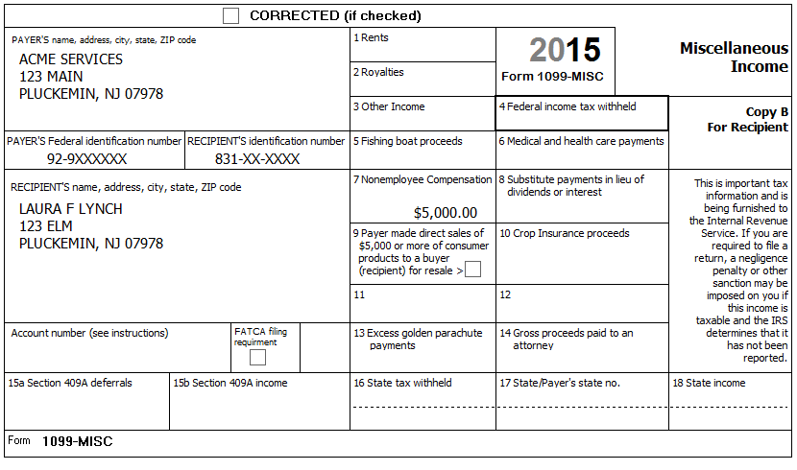
Hint: This is our first 1099-MISC, so after clicking Continue, then click the New button on the “Where would you like to add the income?” screen
Federal Refund: 3,267 NJ Refund Amount: 1,128
Step 7b Sch C – Basic Information
She had no separate business name, no EIN, and no business address (other than her home).
Tool: NAICS Search Tool (link on Preparer page)
Tool: 1040 Instructions, Sch C Business Codes table
Hint: If you can’t find an obvious match in TSO’s built-in Business Code lookup list, then an alternative is to use the online NAICS Search Tool to search for the Business Code (enter keyword “editing” in this case)
Hint: After clicking Continue, you will see the Schedule C menu – Do NOT click on any of these options now – We will come back to these later.
Federal Refund: 3,267 NJ Refund Amount: 1,128
Step 7c 1099-MISC
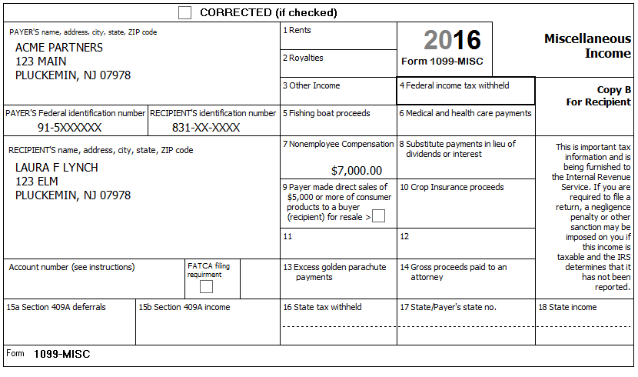
Hint: This is our second 1099-MISC for the same business, so after clicking Continue, just click the Add button for the Document preparation Sch C on the “Where would you like to add the income?” screen. This should bring you back to the Schedule C menu.
Federal Refund: -65 NJ Refund Amount: 594
Step 7d Sch C – Questions About the Operation of Your Business
Click on “Questions About the Operation of Your Business” on the Schedule C menu.
She uses the Cash Accounting Method. She has no inventory. She does all the work for the business herself. There is no Prior year unallowed loss. She made no payments that would require her to file Form(s) 1099. This is not a Qualified Joint Venture
Federal Refund: -65 NJ Refund Amount: 594
Step 7e Sch C – Income
Click on “Income” on the Schedule C menu.
In addition to the 1099-MISC income, she had $176 in cash income.
Federal Refund: -143 NJ Refund Amount: 582

Step 7f Sch C – Car And Truck Expenses
Click on “Car And Truck Expenses” on the Schedule C menu.
Laura drove 366 total miles making deliveries for her business. She had 10,000 other miles on her car. Laura has one car (a 1969 Chevy Impala) which she bought in 2010 and began using for her work when she started working at home. She has a written record of her business mileage.
Hint: See 4012 for suggestion of what to use for “Description of Vehicle”
Federal Refund: -60 NJ Refund Amount: 595
Step 7g Sch C – Other Expenses
Click on “Other Expenses” on the Schedule C menu.
She kept a record of her expenses: $2,025 for paper, $1,048 for printer cartridges, and $8,850 for making copies.
Federal Refund: 5,504 NJ Refund Amount: 1,505
Step 8 Alimony Received
Laura’s divorce decree states that her ex-husband is to pay her $300 per month alimony. Due to the loss of his job during the year, he only paid for 3 months.
Federal Refund: 5,224 NJ Refund Amount: 1,432
Step 9 Sch A Deductions
Laura paid $1,000 for supplemental insurance and $200 to doctors/dentists for co-pays and deductibles. She also had a small amount of charitable donations (with cancelled checks).
Federal Refund: 5,224 NJ Refund Amount: 1,444
Step 10 Child Care Credit
Laura paid Acme Day Care (EIN 93-9XXXXXX), located at 123 Main, Pluckemin, NJ 07978, for George’s and John’s care while she was at work. She paid the day-care center $1,793 ($890 for George + $903 for John).
While looking for work, Laura paid her sister, Edna Loy (SSN 839-XX-XXXX), $400 to take care of John & George ($200 each). Edna lives next door at 121 Elm. Edna is self-supporting.
Hint: Because Laura has earned income, you do not need to fill in anything on “F2441 – Child Care Credit – Page 2”.
Federal Refund: 5,838 NJ Refund Amount: 1,444
Step 11 Health Insurance
The entire household had (non-Marketplace) MEC the whole year.
Federal Refund: 5,838 NJ Refund Amount: 1,444

State Section (New Jersey)
You have collected information during several Federal Steps on your NJ Checklist – It is now time to enter that information into TSO
Step 12a NJ Checklist – Basic Information
Enter New Jersey State Return – Basic Information
Annoyance: You need to click Continue until you get back to the original State Return screen before TSO will recalculate Refunds
Federal Refund: 5,838 NJ Refund Amount: 1,461
Step 12b NJ Checklist – Income Subject to Tax
Enter New Jersey State Return – Income Subject to Tax
Annoyance: You need to click Continue until you get back to the original State Return screen before TSO will recalculate Refunds
Federal Refund: 5,838 NJ Refund Amount: 1,553
Step 12c NJ Checklist – Subtractions from Income
Enter New Jersey State Return – Subtractions from Income
Annoyance: You need to click Continue until you get back to the original State Return screen before TSO will recalculate Refunds
Federal Refund: 5,838 NJ Refund Amount: 1,817
Step 12d NJ Checklist – Credits
Enter New Jersey State Return – Credits
Laura paid $755 per month rent for Jan-Jun and $798 per month for Jul-Dec
Annoyance: You need to click Continue until you get back to the original State Return screen before TSO will recalculate Refunds
Federal Refund: 5,838 NJ Refund Amount: 1,867

Step 12e NJ Checklist – Tax
Enter New Jersey State Return – Tax
Laura did not make any purchases which would be subject to Use Tax.
Hint: Nothing new to do here.
Federal Refund: 5,838 NJ Refund Amount: 1,867
Step 12f NJ Checklist – Payments
Enter New Jersey State Return – Basic Information
Hint: Nothing to do here.
Federal Refund: 5,838 NJ Refund Amount: 1,867
Step 12g NJ Checklist – Miscellaneous Forms
Enter New Jersey State Return – Miscellaneous Forms
Hint: Nothing to do here.
Federal Refund: 5,838 NJ Refund Amount: 1,867

e-File
Collect any final information necessary…
Step 13 E-File – EIC Checklist
Per Pub 4012, the question “Did you complete form 8867 and/or perform the due diligence required based on current information provided by the taxpayer or reasonably obtained by you?” must be answered “Yes”
Answer other questions based on the information you have.
Hint: After clicking Continue, you will see Form 8867 – EIC Checklist. If any button says “Disqualified”, you answered one of the questions wrong.
Step 14a E-File – Return Type
Laura has a Federal refund – she would like a check mailed (per her Intake Sheet)
Hint: Federal Return Type = Electronic Mailed
Step 14b E-File – Tax Preparation and E-File Information
Laura’s email=LauraLynch657483@mail.com
Step 14c E-File – State Return(s)
Laura has a NJ refund – she would like a check mailed (per Interview)
Hint: NJ Return Type = Electronic Mailed
Step 14d E-File – Taxpayer Bank Account Information
Does not apply to this return.
Step 14e E-File – Third Party Designee Info
Hint: Do NOT fill in anything here.
Step 14f E-File – Questions
Laura is not a Veteran from the US Armed Force
Hint: Click Save when done
Step 14g E-File – Submission
BP: Click “Ready for Review” at the bottom of this screen

